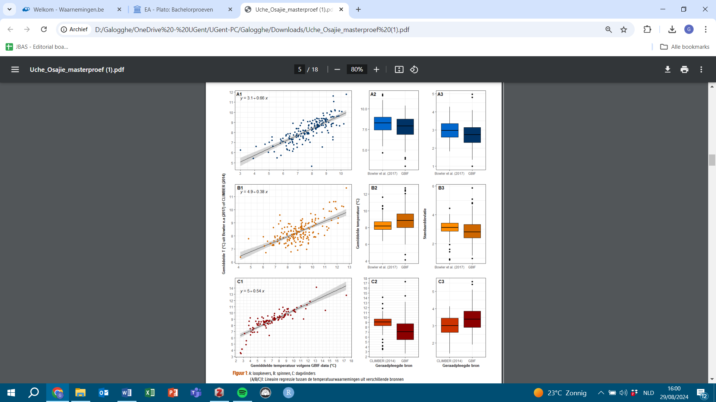
S.2.2: linear regressions between temperature estimates
Mean temperature based on literature (°C)
Mean temperature based on GBIF (°C)

Figure S.2.2: Linear regressions between temperature estimates from literature and our calculations based on GBIF distribution data. Three different arthropod groups were assessed based on available literature data: (A) Carabidae, (B) Araneae and (C) Rhopalocera. Literature values were derived from Schweiger et al. (2014) and Bowler et al. (2017). The figure is adapted from the bachelor thesis of Uche Osajie (2021).

